Федеральное агентство связи

Федеральное государственное бюджетное образовательное учреждение

высшего образования

«Сибирский государственный университет

телекоммуникаций и информатики»

**Лабораторная работа по теме:**

**«JNI»**

Выполнил:

Студент 4 курса

ИВТ, гр. ИП-712

Алексеев С.В.

Новосибирск 2020 г.

Оглавление

**Элементы оглавления не найдены.**

# Задание

Написать программу, рисующую куб с текстурой.

Вся прорисовка должна быть реализована в JNI.

# Скриншоты

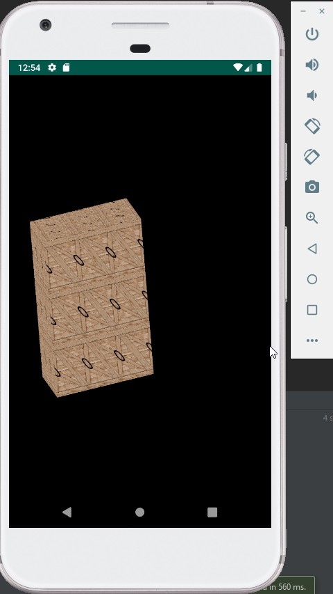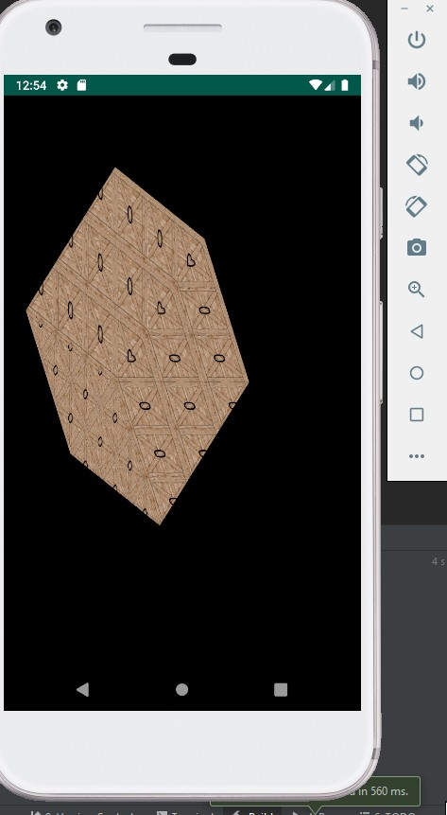

# Листинг

JNIWrapper.java

package com.example.lab7;  
  
public class JNIWrapper {  
  
 static {  
 System.*loadLibrary*("native-lib");  
 }  
  
 public static native void onSurfaceCreated();  
  
 public static native void onSurfaceChanged(int width, int height);  
  
 public static native void onDrawFrame();  
}

MainActivity.java

package com.example.lab7;  
  
import android.app.Activity;  
import android.app.ActivityManager;  
import android.content.Context;  
import android.content.pm.ConfigurationInfo;  
import android.opengl.GLSurfaceView;  
import android.os.Build;  
import android.os.Bundle;  
import android.widget.Toast;  
  
public class MainActivity extends Activity {  
  
 private GLSurfaceView glSurfaceView;  
 private boolean rendererSet;  
  
 private boolean isProbablyEmulator() {  
 return Build.*FINGERPRINT*.startsWith("generic") || Build.*FINGERPRINT*.startsWith("unknown")  
 || Build.*MODEL*.contains("google_sdk") || Build.*MODEL*.contains("Emulator")  
 || Build.*MODEL*.contains("Android SDK built for x86");  
 }  
  
 @Override  
 protected void onCreate(Bundle savedInstanceState) {  
 super.onCreate(savedInstanceState);  
  
 ActivityManager activityManager  
 = (ActivityManager) getSystemService(Context.*ACTIVITY_SERVICE*);  
 ConfigurationInfo configurationInfo = activityManager.getDeviceConfigurationInfo();  
  
 final boolean supportsEs2 =  
 configurationInfo.reqGlEsVersion >= 0x20000 || isProbablyEmulator();  
  
 if (supportsEs2) {  
 glSurfaceView = new GLSurfaceView(this);  
  
 if (isProbablyEmulator()) {  
 // Avoids crashes on startup with some emulator images.  
 glSurfaceView.setEGLConfigChooser(8, 8, 8, 8, 16, 0);  
 }  
 glSurfaceView.setRenderer(new RendererWrapper(this));  
 rendererSet = true;  
 setContentView(glSurfaceView);  
 } else {  
 // Should never be seen in production, since the manifest filters  
 // unsupported devices.  
 Toast.*makeText*(this, "This device does not support OpenGL ES 2.0.",  
 Toast.*LENGTH_LONG*).show();  
 return;  
 }  
 }  
  
 @Override  
 protected void onPause() {  
 super.onPause();  
  
 if (rendererSet) {  
 glSurfaceView.onPause();  
 }  
 }  
  
 @Override  
 protected void onResume() {  
 super.onResume();  
  
 if (rendererSet) {  
 glSurfaceView.onResume();  
 }  
 }  
}

RendererWrapper.java

package com.example.lab7;  
  
import android.content.Context;  
import android.graphics.Bitmap;  
import android.graphics.BitmapFactory;  
import android.opengl.GLSurfaceView;  
import android.opengl.GLUtils;  
  
import java.io.InputStream;  
  
import javax.microedition.khronos.egl.EGLConfig;  
import javax.microedition.khronos.opengles.GL10;  
  
class RendererWrapper implements GLSurfaceView.Renderer {  
 static public int[] *texture_name* = {  
 R.drawable.*cube* };  
  
 Context c;  
  
 public RendererWrapper(Context context) {  
 c = context;  
 }  
  
 static public int[] *textures* = new int [*texture_name*.length];  
  
  
 private void loadGLTexture(GL10 gl) {  
 gl.glGenTextures(1, *textures*, 0);  
 for (int i = 0; i < *texture_name*.length; ++i) {  
 gl.glBindTexture(GL10.*GL_TEXTURE_2D*, *textures*[i]);  
 gl.glTexParameterf(GL10.*GL_TEXTURE_2D*, GL10.*GL_TEXTURE_MIN_FILTER*, GL10.*GL_LINEAR*);  
 InputStream is = c.getResources().openRawResource(*texture_name*[i]);  
 Bitmap bitmap = BitmapFactory.*decodeStream*(is);  
 GLUtils.*texImage2D*(GL10.*GL_TEXTURE_2D*, 0, bitmap, 0);  
 bitmap.recycle();  
 }  
 }  
  
  
 @Override  
 public void onSurfaceCreated(GL10 gl, EGLConfig config) {  
 loadGLTexture(gl);  
 JNIWrapper.*onSurfaceCreated*();  
  
 }  
  
 @Override  
 public void onSurfaceChanged(GL10 gl, int width, int height) {  
 JNIWrapper.*onSurfaceChanged*(width, height);  
 }  
  
 @Override  
 public void onDrawFrame(GL10 gl) {  
 gl.glBindTexture(GL10.*GL_TEXTURE_2D*, *textures*[0]);  
 JNIWrapper.*onDrawFrame*();  
 }  
}